Another Delicious Recipe From
www.SimpleBrunchIdeas.com

Slow Cooker Lamb Stew

Ingredients  1 onion, sliced  2 lb lamb, cut into 1” cubes  2 cups carrots, large baby carrots or 1” slices  2 cups potatoes, 2” pieces  28oz can crushed tomatoes  15oz can garbanzo beans  ¼ cup flour  2 tablespoons pepper  1 teaspoon salt  2 tablespoons olive oil  2 cups water | 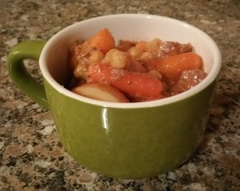

Directions
- Put flour, salt, pepper and lamb in plastic food storage bag and coat meat evenly.
- Brown the meat over medium-high heat in olive oil, working in batches to brown the edges of the meat without cooking through. Use slotted spoon to transfer meat from skillet to crockpot.
- Add onion to same skillet and sauté until golden brown, scraping up the remaining bits of lamb.
- Add cooked onions, and remaining ingredients to the crockpot.
- Cover and cook on low for 8 to 10 hours.

