Blanched Asparagus  Ingredients  1½ pound thin asparagus spears  Boiling water / Ice water  2 tablespoons salt (optional) | 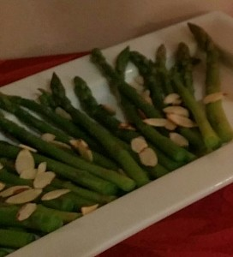

Directions
- Rinse asparagus well. Trim off thick ends.

- In a large saucepan, bring salted water to a boil.

- Add asparagus and boil just until tender, 1 to 2 minutes.

- Drain asparagus and immediately submerge in ice water to stop the cooking process.

- Drain and refrigerate until completely chilled.

